

Ort Braude College

**Childhood ADHD Symptom Detection with Possible Solutions**

**24-1-D-6**

Safwan Halabi – 213784127

Bishara Bisharat – 208261990

Mentor: Dr. Natali Levi

# Table of Contents

Table of Contents 2

1. Introduction 3

1.1 General description of the problem: 3

1.2 Current available solutions to diagnose symptoms: 4

1.3 What do we plan on doing and how will it help solve the issue: 4

1.4 Beneficiaries 4

2. Background 5

2.1. Symptom Detection 5

2.1.1 Behavior: 5

2.1.2 Environment: 5

2.1.3 Vocal Characteristics: 5

2.1.4 Eye Movement/Eye-Tracking: 6

2.2. Gender 6

2.3. Treatment 6

2.3.1 Medication 6

2.3.2 Behavior therapy 7

2.4. Risks 7

2.4.1 Risks of symptom detection 7

2.4.2 Risks of symptom development 7

3. Expected Achievements 7

3.1 Outcomes 7

3.2 Criteria for Success 8

4. The Process 8

4.1 Research - Vocal Analysis 8

4.1.1 Constraints and Challenges - Vocal analysis 8

4.2 Research - Eye Tracking 9

4.2.1 Constraints and Challenges - Eye-Tracking 9

4.3 Research - Deep Learning and AI 9

4.3.1 Constraints and Challenges - Deep Learning and AI 9

4.4 Development 10

5. The Product 11

5.1 System Requirements 11

5.1.1 Functional: 11

5.1.2 Non-Functional: 11

5.2 Project Architecture 12

5.3 WEB Application 13

5.4 Test Pages 17

5.5 Deep Learning Prediction Model: 20

5.6 Diagrams 21

5.6.1 Sequence Diagram 21

5.6.2 Class Diagram: 22

5.6.3 Use-Case Diagram: 22

6. Evaluation 23

6.1 Model Evaluation 23

6.2 Testing plan 23

7. References 25

**Abstract**

Motivated by the increasing number of undiagnosed Attention Deficit Hyperactivity Disorder (ADHD) cases, often linked to expensive traditional testing, this project presents a web application to aid in ADHD detection in children. This application employs a multi-modal approach, utilizing novel techniques like vocal and eye-tracking assessments alongside standardized caretaker questionnaires to gather comprehensive data. On the back end, a trained Artificial Intelligence model analyzes this data stored in a MongoDB instance. This model, trained on historical data from previously diagnosed children, predicts the likelihood and severity of potential ADHD symptoms in the tested child. This web application offers a potentially objective and convenient method for initial ADHD screening. By combining these novel assessments with caregiver reports, it aims to provide a more comprehensive picture of possible ADHD compared to traditional methods. Future work will involve validating the AI model's accuracy through clinical trials and potentially expanding the functionalities of the web application to further enhance its effectiveness. It's important to note that this application does not diagnose ADHD, but rather helps with detecting possible symptoms, allowing individuals to seek further professional evaluation.

# Introduction

## 1.1 Problem

ADHD (Attention Deficit Hyperactivity Disorder) and it’s less hyperactive counterpart ADD (Attention Deficit Disorder) are some of the most common neurobehavioral disorders and they are especially rampant in children, according to Golden Steps ABA around 5.3% of children worldwide suffer from ADHD (approximately), these disorders can be extremely disruptive for these children as they grow up and could lead to devastating results yet they all usually fly under the radar until later stages in the patient’s life.

ADHD is a disease that’s characterized by 3 distinct categories of symptoms: Inattention, Hyperactivity and Impulsivity, although these 3 categories are directly linked to ADHD, clinicians and researchers are still struggling to uncover the root cause of the disorder. Each patient has specific tendencies and the severity of each symptom varies from patient to patient, but they all fall under the same umbrella, here are some common traits that ADHD patients usually share: forgetfulness, doing before thinking, getting distracted easily, difficulty attending to the details, etc.

What’s reassuring about this problem is that if it was identified at an early stage, it’s possible to treat it. To quote the British National Health Service “With appropriate intervention, children with ADHD can lead normal lives”.

## 1.2 Available Solutions

As of today, there are several ways to discover early signs of ADHD in children, and they are mostly done by a licensed professional. One of these ways is medical examination, where the family consults a medical professional, in which the child undergoes a series of check-ups potentially leading to a concise diagnosis. Another way is more of a general solution, which involves a third-party observer, usually a teacher, that monitors the child’s behavior for an extended period, with the purpose of identifying certain behaviors that could allude to the child having symptoms of ADHD. There are also questionnaires such as Conners Rating Scale. This questionnaire asks various questions including general behavior, schoolwork and social life, and provides insights about how these symptoms affect different aspects of the child’s life such as grades, home and relationships.

## 1.3 Our Solution

We plan on building a mathematically based AI model that takes in various parameters and metrics provided by the user about their child’s behavior and the model will predict whether they potentially have ADHD based on the severity of their symptoms and suggest various solutions and day-to-day habits to help children combat their sickness.

Our aim is to provide an easy and accessible way to help families all around the world to a fair warning that could save their child from a problem that can impact most of their lives.

## 1.4 Beneficiaries

Our beneficiaries are children with undiagnosed ADHD as well as their families, our model is set to inform said families about their kids potentially having ADHD and the severity of their symptoms as well as proposing various solutions and suggesting getting tested.

# Background

## 2.1. Symptom Detection

Throughout the years doctors and medical professionals have developed several methodologies to detect possible ADHD symptoms, many of which were questionnaires and simple tests conducted by therapists to both the patients and their parents[18]. It’s highly recommended for parents to be educated about the disorder and its symptoms[2], thus increasing the probability of detecting these symptoms in their children, which could help with treating the child at an early stage.

ADHD symptoms are observed in 4 different domains:

### 2.1.1 Behavior:

There are various behavioral trends that ADHD patients commonly exhibit. One of them is inability to pay attention for a set amount of time. Other common symptoms include constantly feeling the need to do physical activities, not thinking before doing, talking too much, inability to wait their turn and more[14].

Such symptoms shouldn’t be taken at face value, considering ADHD’s known comorbidity with other psychiatric conditions such as depression, anxiety, learning and conduct disorders[12]. Approximately 60% of patients with ADHD have other impairments as well[16]. As a result, patients often require the help of a trained professional as well as comprehensive tests to successfully be diagnosed and attribute the symptoms to ADHD.

### 2.1.2 Environment:

Environmental variables play a pivotal role in the development of ADHD, research papers[16,17] show us that parameters as exposure to toxins during childhood, cigarette smoking, and socio-economic status were found to be potential factors in developing ADHD, as well as parents’ behavior and clinical status which were found to be potential factors in developing ADHD as a child.

### 2.1.3 Vocal Characteristics:

Children with ADHD significantly show signs of vocal hyperactivity, and have more hoarseness, excessive emission of breath, and straining in their voice[1,3,5,10,13]. Moreover, it has been shown that ADHD is a risk factor for development for vocal fold nodules[14]. Therefore, children with ADHD should undergo a multimodal management plan accompanied by vocal therapy[14].

It has been shown that ADHD is a risk factor for development for vocal fold nodules[14]. Nodules are characterized by bilateral thickening at the junction of the anterior and middle thirds of the vocal folds. Histological analyses of vocal fold nodules have revealed proliferation of the epithelial layers, thickening of the basal membrane and the presence of fibronectin in the superficial layer of the lamina propria.

### 2.1.4 Eye Movement/Eye-Tracking:

Studies[7,8] concluded that eye movements could be a viable metric to determine the severity of symptoms, especially inattention and hyperactivity. Moreover, integrating eye-tracking tests lead to more accurate results in terms of diagnosis[7,8].

One eye tracking test is called “The Fixation Task, Continuous Inhibition and Selective Attention”, which showed a clear distinction between ADHD patients and the Healthy Control Groups[7,8]. In *The Fixation Task* the patient fixates on a specific point while providing him various distractions. The purpose of it is to test how many times did the patient’s pupils move towards these distractions.

Two other meaningful tests are (1) “Continuous Inhibition” in which the patient presses a button when he sees any figure, except a pre-determined specific figure (I.E. the shape X), at the center of the monitor. The test will count wrong pressings. And (2) “Selective Attention” in which the patient presses a button quickly when they see a circle figure at the center of the monitor. The test with track the reaction time.

## 2.2. Gender

Studies have found that boys and girls who suffer from ADHD behave differently. Therefore, a different approach is required for dealing with a child, whether we are trying to detect symptoms or trying to help them.

ADHD is more frequently diagnosed in males. Females with ADHD had better and more accurate self-reports about symptoms while boys with ADHD were more accurate with an external report (a parent or teacher filed a symptom report for them)[15], Boys tend to have more externalizing symptoms while girls have more internalizing symptoms[14] what cause to girls be underdiagnosed compared to boys[15].

## 2.3. Treatment

Educating people about ADHD is a crucial step for a treatment. It’s highly recommended for parents, along with school staff, to be aware to ADHD symptoms and referring them to a professional at an early stage which is essential[4, 11]. Studies have shown that the optimal treatment of ADHD is a multimodal approach consisting of medication and behavioral therapy[4,11,12,14].

### 2.3.1 Medication

Stimulants are used for the treatment of ADHD and are generally considered as safe medications. Clinicians begin with a low dose of medication and titrate upward, depending on the patient’s response to the drug[4]. At least 80% of children will respond to one of the suggested stimulants (Ritalin, Methylin, Concentra, Adderall etc.) if they are tried in a systematic way[4]. Although medications tremendously help with the treatment, many studies of stimulants have been short term.

### 2.3.2 Behavior therapy

A broad set of interventions that have a common goal of modifying the physical and social environment to alter or change behavior. It’s usually implemented by including the parents and teachers. Parent training improves the parent’s understanding of the child’s behavior and helps them deal with difficulties posed by ADHD. Classroom management also may improve a child's behavior and begins with increasing the structure of activities: systematic rewards and consequences. Behavior therapy has been demonstrated to be effective only while it is implemented and maintained.

## 2.4. Risks

There are potential risks associated with both the presence of ADHD and the process of diagnosing ADHD.

### 2.4.1 Risks of symptom detection

As mentioned above, there are various risks with ADHD symptom detection, most notably is “misdiagnosis”. ADHD is commonly comorbid with other mental conditions such as anxiety and depression. A long-term observation of a child's behavior through schools and parents is required for having an accurate ADHD diagnosis[6,11].

### 2.4.2 Risks of symptom development

Studies have found that a lack of parental knowledge could lead to worsening ADHD symptoms in their children[4,11]. In addition, the existence of ADHD in parents has a significant impact on increasing the severity of the ADHD symptoms in their child[11].

# Expected Achievements

## 3.1 Outcomes

In this project we strive to provide new, widespread, and readily available way to detect potential ADHD symptoms early on in a patient’s life. The status quo dictates that such information be locked behind a hefty sum of money and is only provided by people who are authorized to work with professional toolsets, such as doctors, clinicians and experts in the field of medicine.

Our project will be used to conduct several tests on children, some of them are eye-based and some are vocal-based tests (several studies have found a connection between ADHD and said tests), the performance of patients will be analyzed and compared to diagnosed ADHD children and a control group scores.

Our tool will then provide insights on the test results and overall assessment of the patient’s condition, followed by suggested actions to cope with the disorder had the patient received a reasonably high score by our tool.

## 3.2 Criteria for Success

* Implementation of scientifically proven and credible tests
* Easy-to-use interface.
* Easy to understand test results and analyses.
* The project should suggest useful tips and logical next steps.
* The ability to accurately measure eye-movements and vocal ranges.
* Correctly identifying ADHD symptoms based on the tests conducted.
* Able to take ADHD subtypes into consideration.
* Short and concise tests, relatively short duration.

# The Process

## 4.1 Research - Vocal Analysis

In order to adequately implement vocal analysis into our project we reviewed current literature about the subject. Many research papers have found the credibility of utilizing this technology to aid in diagnosing ADHD.[3, 5, 6, 10]

### 4.1.1 Constraints and Challenges - Vocal analysis

There are many challenges that our product has to conquer when it comes to vocal analysis- many of which are technical and hardware related issues, some of the main points of each category are:

**Hardware:**

* **Accuracy**: Microphone quality and background noise can significantly impact the accuracy of vocal analysis.
* **Noise Suppression and Filtering**: Many modern microphones have filtering and noise suppression options as the default, both of which can possibly interfere with voice being recorded.

**Technical:**

* **Device Compatibility**: The app has to work with and adapt to different devices with varying microphone quality.
* **Background Noise**: Noisy environments can render vocal analysis unusable.

## 4.2 Research - Eye Tracking

Our research of eye-tracking included understanding the fundamentals of the subject as well as closely examining various projects that make use of the same technology along with possible libraries that could help us implement our solution such as OpenCV, Numpy.

### 4.2.1 Constraints and Challenges - Eye-Tracking

Publicly available eye-tracking solutions are abundant, but many fall short of our project's specific needs. Here, we outline the most critical constraints that limit our options.

* **Accuracy**: Precise eye-tracking hinges on a high-resolution camera that captures clear images of the user's eyes. Inaccurate data can lead to misinterpretations of gaze patterns and hinder the effectiveness of our project.
* **Stability and Calibration**: The camera system requires stability and consistent calibration. Even minor jitters or inconsistencies can disrupt the data stream and compromise the software's ability to analyze eye movements effectively.
* **Environmental Conditions**: Factors like fluctuating light levels, lens flare (caused by reflections), or sudden movements in the user's field of view can disrupt eye tracking.

## 4.3 Research - Deep Learning and AI

During the research process we relied on current research[19] about Deep Learning, specifically focusing on its application on ADHD and similar disorders’ diagnosis and classification.

### 4.3.1 Constraints and Challenges - Deep Learning and AI

While Deep Learning and AI offer tremendous potential, there are challenges to consider when integrating them into large-scale projects:

* **Data Availability and Quality:** Deep Learning models require large amounts of high-quality data for effective training. Large software projects may have complex data structures or lack the data needed to train robust AI models.
* **Model Development and Maintenance:** Developing and maintaining effective AI models requires expertise and resources. Ongoing updates and improvements are crucial to ensure model performance and accuracy.
* **Explainability and Transparency:** Understanding how AI models arrive at their decisions can be difficult. For large projects, ensuring transparency and explainability in AI decision-making might be critical.

## 4.4 Development

**Agile Development with Iterative Testing**

We believe the Agile methodology, with its emphasis on iterative development and testing, is a perfect fit for this project. This approach aligns well with our development process because each test, like eye-tracking or vocal analysis, can be built and tested independently. This allows for faster feedback and continuous improvement.

Here's a breakdown of the key development steps we'll follow using an Agile approach:

1. **Test Implementation**: Each test (eye-tracking and vocal analysis) will be developed in sprints, which are short development cycles within Agile methodology. During each sprint, a small, focused set of features will be implemented for each test. This allows for quicker testing and feedback loops.

2. **Data Integration and Comparison**: After implementing a test, we'll integrate patient data collection and compare the results with our research findings. This will help us evaluate the effectiveness of each test in identifying ADHD symptoms.

3. **Classification and Accuracy Assessment**: We'll develop a system to classify patients based on the combined test results. This classification will be presented with a predicted accuracy level, allowing us to track the tool's performance over time.

4. **Web-based User Interface (UI) Development**: We'll create a user-friendly web interface where patients can take the tests and view their results. The UI will be designed iteratively, with user feedback incorporated at each stage.

5. **Text-Bot Integration**: To enhance user experience, we'll integrate a text-bot into the UI. This bot can provide guidance and answer questions as users navigate the website and review their results.

6. **Iterative Testing and Evaluation**: After each development sprint, we'll conduct thorough testing to ensure all functionalities are working as expected. We'll also continuously evaluate the overall product against pre-defined success criteria.

7. **Agile Iteration and Improvement**: If any issues or areas for improvement are identified during testing or evaluation, we'll use subsequent sprints to address them. This iterative approach allows for continuous refinement and ensures the final product is robust and meets user needs.

By adopting Agile methodology, we can ensure a flexible and efficient development process. This allows us to adapt to new findings, refine functionalities, and ultimately deliver a valuable tool for ADHD assessment.

# The Product

## 5.1 System Requirements

### 5.1.1 Functional:

|  |  |
| --- | --- |
| 1 | The system will use a webcam |
| 2 | The system will use a microphone |
| 3 | The system will use a keyboard |
| 4 | The system will have a questionnaire about a patient’s behavior |
| 5 | The system will have a trainable AI model |
| 6 | The system will have a WEB based interface |
| 7 | The system can share data between the webcam and the WEB interface |
| 8 | The system can share data between the microphone and the WEB interface |
| 9 | The system can share data between the keyboard and the WEB interface |
| 10 | The system will conduct multiple tests |
| 11 | The system will store test data in database |
| 12 | The system will analyze data and produce behavior treatments using the model |
| 13 | The system will display analysis and results in WEB interface |

### 5.1.2 Non-Functional:

|  |  |
| --- | --- |
| 1 | Easy to use interface for the users |
| 2 | Supports all webcams and microphones |
| 3 | Tests should be concluded in a short amount of time |
| 4 | Analysis should be straightforward and easy to understand |
| 5 | Analysis will include instructions for the caregivers |

## 5.2 Project Architecture

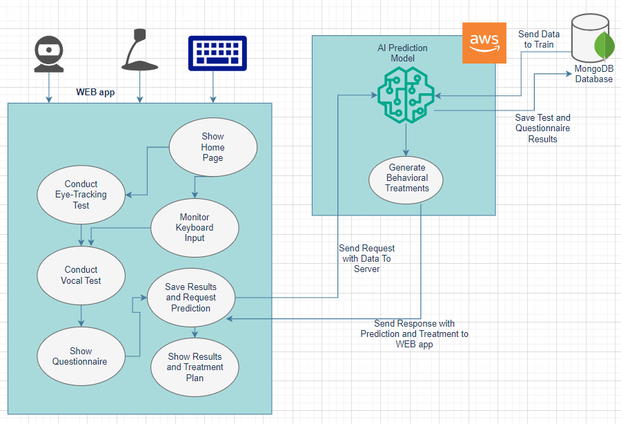

5.2.1 Project Overall Architecture

5.2.2 MVC Model

**Model**

Our MongoDB instance will act as the data storage for this project. It will receive test results and questionnaire answers from the Controller and be responsible for storing them securely.

**Controller**

The Controller layer will handle user interactions. It will initiate the test interfaces (vocal and eye-tracking) and the questionnaire. It will then receive the test results and questionnaire answers from the user and store them in the Model (MongoDB) without any child-specific identifiers. Additionally, the Controller will trigger the AI model for prediction when both tests and questionnaires are completed. It will receive the predicted severity from the model and store it along with the corresponding test and questionnaire identifiers in the Model.

**View**

The View layer is responsible for presenting the user interface. This includes displaying the test interfaces for vocal and eye-tracking tests, as well as the questionnaire for caregivers to fill out. The View will also present the predicted ADHD severity index to the user after the prediction process is complete. Here, it can optionally show details of the tests and the questionnaire used for prediction but ensure that this information doesn't reveal any details about the child.

This way our app separates the concerns of data storage (Model), user interaction handling and prediction (Controller), and user interface presentation (View). It adheres to the privacy requirements by not storing child data and focuses on the test results, questionnaire answers, and the resulting predictions.

## 5.3 WEB Application

This section outlines the technical specifications and functionalities of the web application that will be the user interface for this project. The application will be accessible through a web browser, allowing users to interact with the system and receive test results. The following sections detail the chosen technologies, framework, and libraries used to build the application, ensuring a user-friendly and informative experience.

* **Simplifying Results for Clear Understanding**: We've prioritized a user-friendly interface to make grasping your test results a breeze. Our web application leverages cutting-edge tools to deliver a smooth experience.
* **React/WIX - Building Dynamic User Interfaces**: For the **Front-End** section of our project we decided to use **React/WIX**, a popular open-source library, empowers developers to build dynamic and interactive user interfaces for web applications. Its component-based architecture allows for the creation of reusable UI building blocks, promoting clean and maintainable code. React utilizes a declarative approach, where developers describe the desired state of the UI, and the library efficiently updates the actual web page structure through a virtual DOM, ensuring optimal performance and a smooth user experience.

WIX provides a rough sketch of the WEB pages, said design could be used as is in the final product.

* **Django - Powering Web Development with Speed and Efficiency**: For the **Back-End** section of our project we decided to use **Django**, a high-level Python web framework that offers a robust and efficient foundation for building complex web applications. Favored for its clean design and rapid development capabilities, Django provides a collection of pre-built components and functionalities that handle common web development tasks like database access, user authentication, and URL routing. This streamlined approach allows developers to focus on the core logic and unique features of their application, expediting the development process and fostering code reusability.

We provided sketches of the WEB application in the following pages.

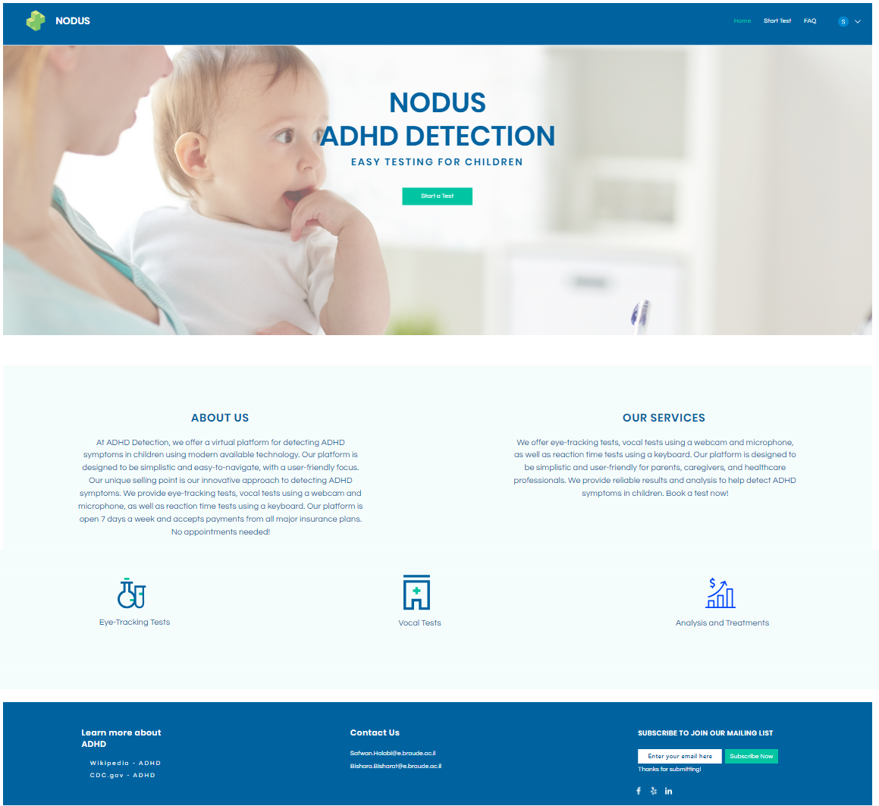

5.3.1 The WEB App’s Home Page

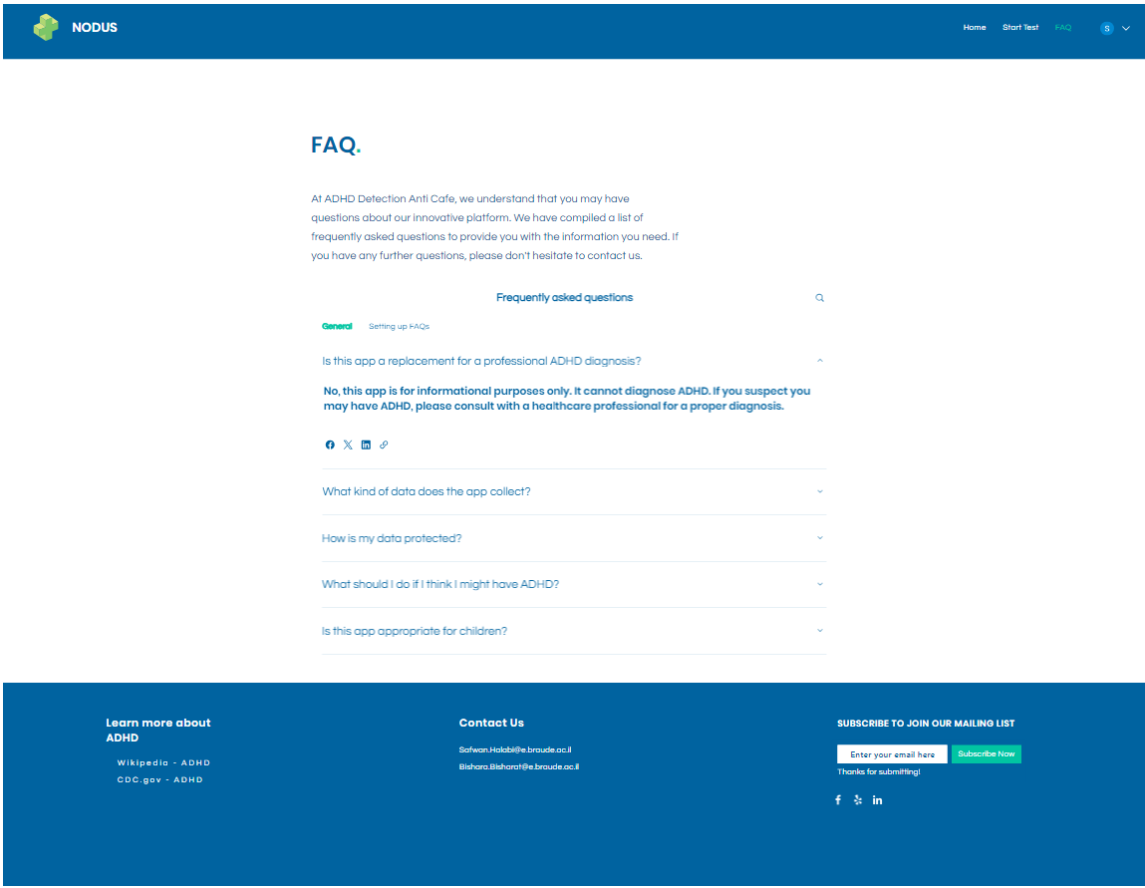

5.3.2 The WEB App’s FAQ Page

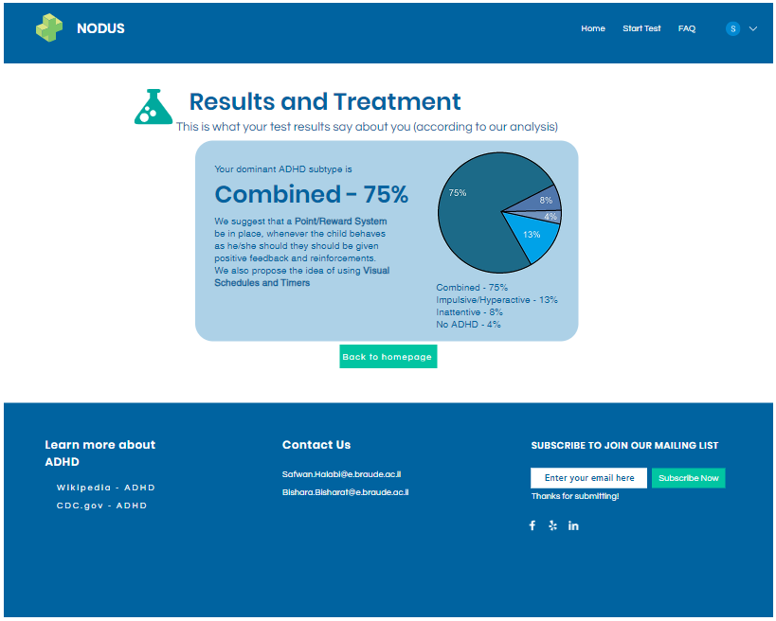

5.3.3 Results and Treatment Page

## 5.4 Test Pages

The WEB application will have 3 test pages: Eye-Test, Vocal-Test and a Questionnaire meant for the child’s caregivers to fill out (I.E a parent or a teacher etc.).

1. The first page is the Eye-Test page, which has 2 components that the app is monitoring at all times: the child’s **pupil position** and the **time** it takes for the child to provide a keyboard input based on what’s written in the middle red-dot (**reaction-time**).

**The following image shows an idea of what the eye-tracking test will look like but it is not final, this is merely a demonstration for visual purposes only!**

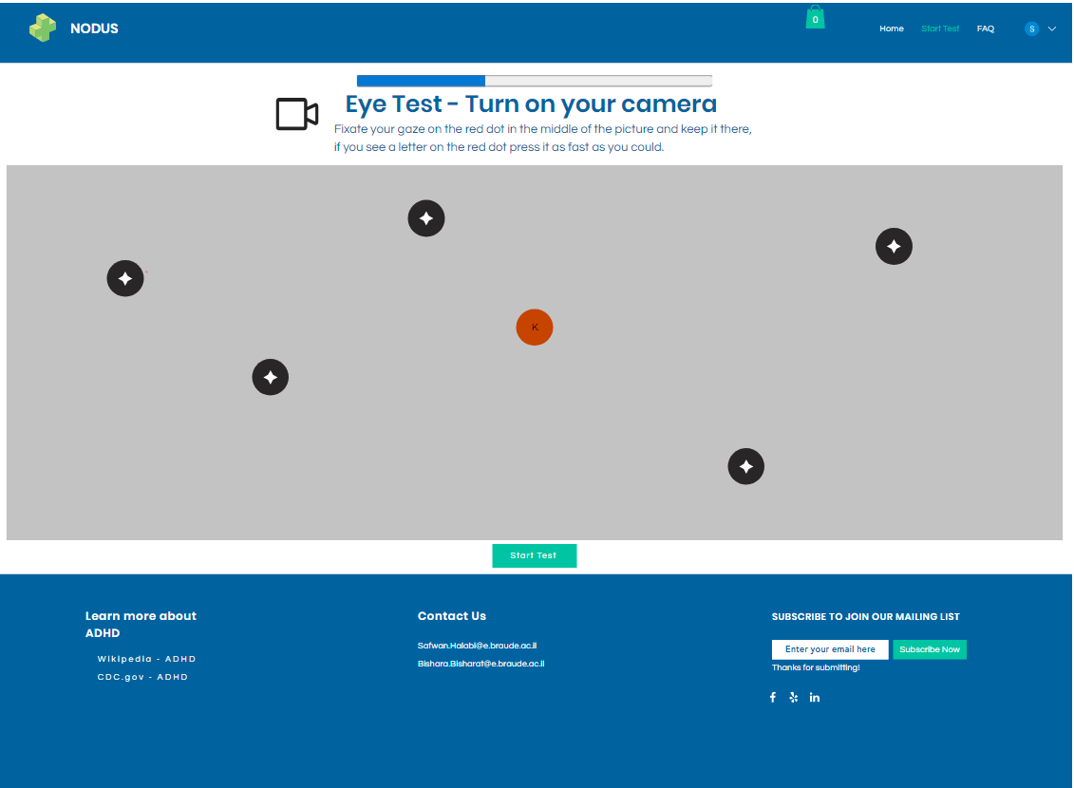

5.4.1 Eye-Movement and Reaction Time Test Page

2. The second page is the Vocal-Test page, which has a **list of words** for the child to read out loud into a microphone.

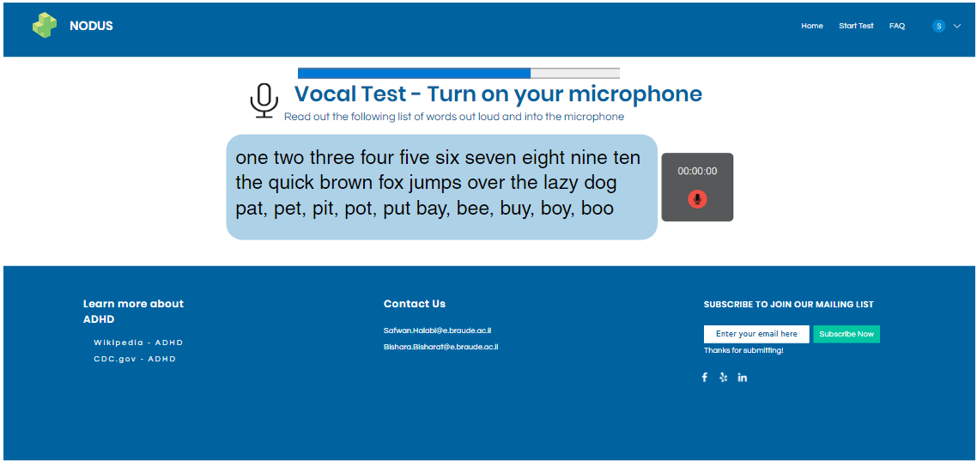

5.4.2 Vocal Test Page

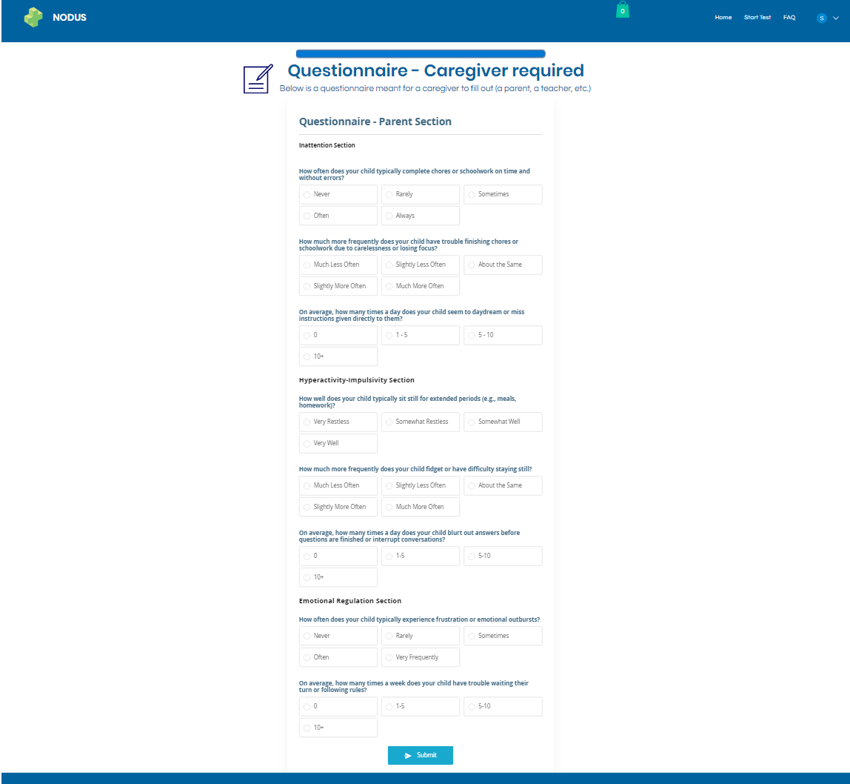

5.4.3 Parent’s Questionnaire Page

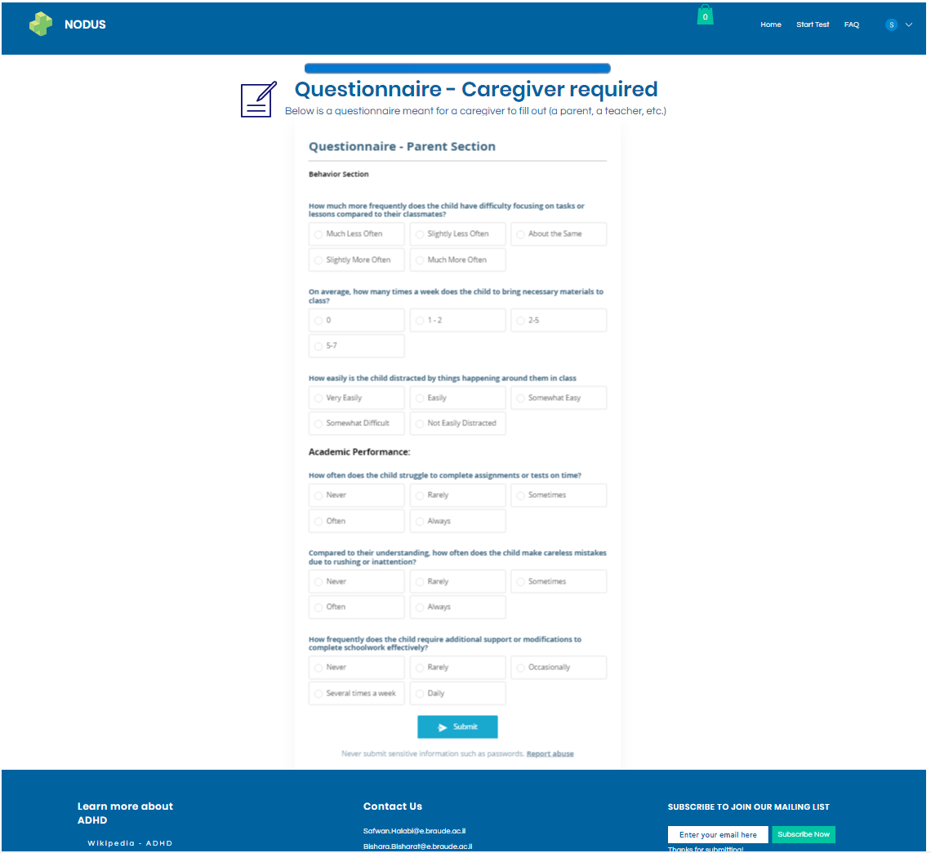

5.4.4 Teacher’s Questionnaire Page

## 5.5 Deep Learning Prediction Model:

This project utilizes a deep learning model to predict the presence of ADHD symptoms in users based on a combination of data sources:

* **Eye-data**: This could include features extracted from eye-tracking data, such as fixation duration, saccade velocity, or pupil dilation. These features may provide insights into attention patterns and focus.
* **Vocal data**: Vocal data analysis might involve features like speech rate, pitch variation, or articulation patterns. These features could potentially reveal subtle differences in communication patterns associated with ADHD.
* **Reaction time**: Reaction time tasks can measure how quickly a user responds to stimuli. Analyzing response times may offer clues about processing speed and impulsivity.
* **Behavioral questionnaire results**: Self-reported or caregiver-reported behavior through questionnaires can provide valuable information about core ADHD symptoms, such as inattention, hyperactivity, and impulsivity.

**Model Architecture**:

The specific deep learning model architecture will be chosen based on the characteristics of the data and the desired outcome. Here are some potential options:

* **Multimodal Deep Learning**: This approach utilizes separate sub-networks to process each data type (eye, vocal, reaction time) independently. The outputs from these sub-networks are then combined and fed into a final network for classification (ADHD symptoms present or absent).
* **Long Short-Term Memory (LSTM) Networks**: LSTMs excel at handling sequential data, making them suitable for analyzing eye-tracking data or vocal patterns that unfold over time.
* **Convolutional Neural Networks (CNNs)**: CNNs are powerful for extracting features from visual data. If eye-tracking data includes information about gaze location on a screen, CNNs could be used to identify patterns.

**Model Training and Evaluation**:

The model will be trained on a labeled dataset containing eye-data, vocal-data, reaction time measurements, and corresponding behavioral questionnaire results indicating the presence or absence of ADHD symptoms. The model's performance will be evaluated using metrics like accuracy, precision, and recall on a separate hold-out test set.

We will expand on the evaluation and testing in the next chapter of the book.

**Ethical Considerations**:

It is crucial to consider the ethical implications of using this model. The model's performance will be thoroughly evaluated to ensure fairness and mitigate bias. Additionally, it's important to emphasize that the model's output is intended as a screening tool, not a definitive diagnosis.

## 5.6 Diagrams

### 5.6.1 Sequence Diagram

The following Sequence Diagramshows how the symptom detection process is conducted.

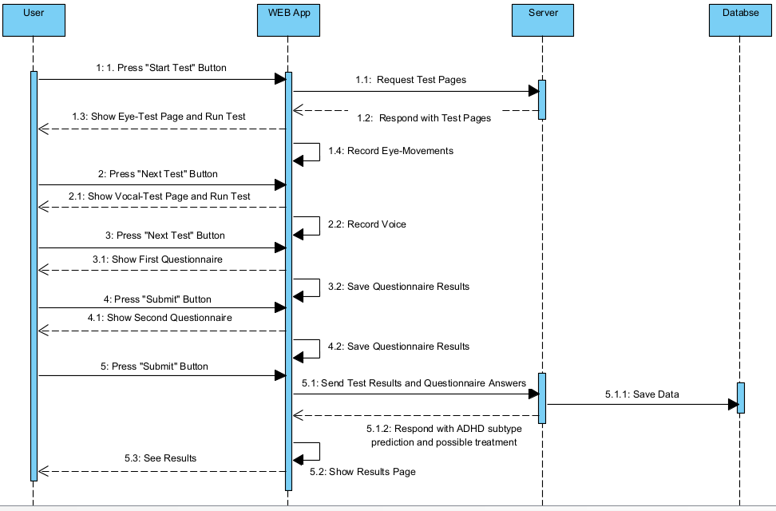

5.6.1 Sequence Diagram

### 5.6.2 Class Diagram:

The following Class Diagram shows the relationship between active objects in our system.

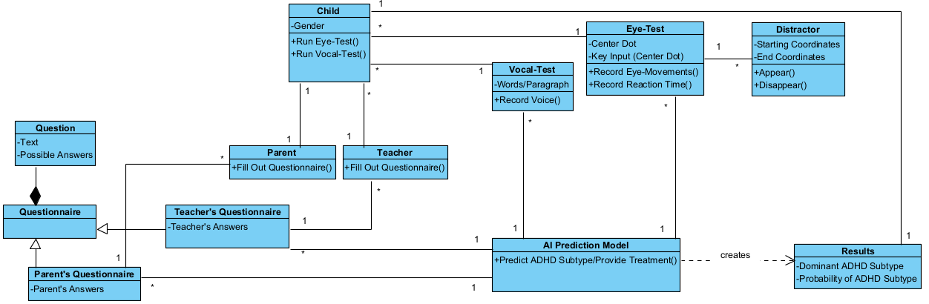

5.6.2 Class Diagram

### 5.6.3 Use-Case Diagram:

The following Use-Case Diagram shows all the different functionalities the user can access and operate in our system.

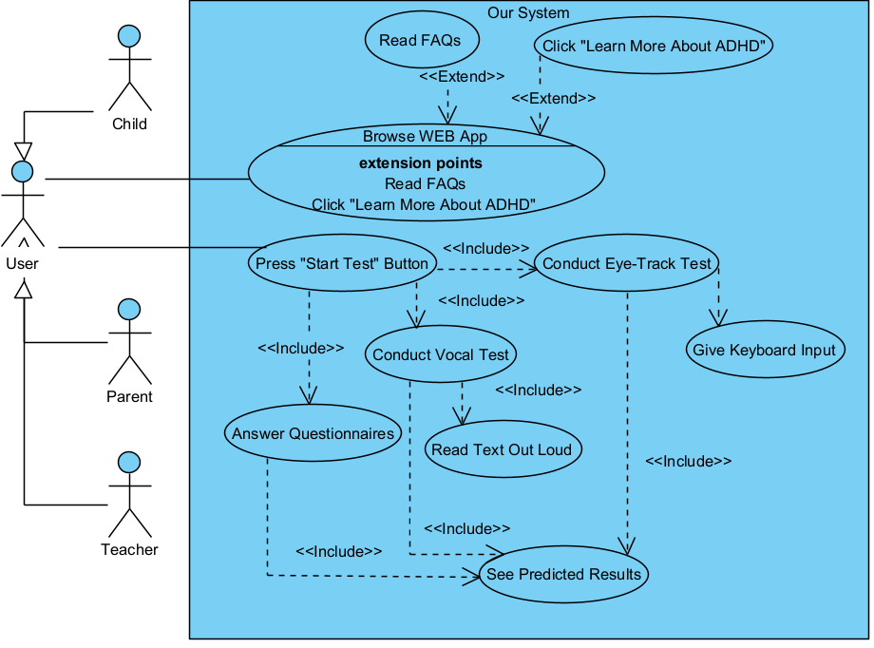

5.6.3 Use-Case Diagram

# Evaluation

## 6.1 Model Evaluation

To comprehensively evaluate our model's ability to identify ADHD, we will conduct a rigorous assessment. This evaluation will involve training a deep learning model on a combination of test and questionnaire results. The model will be designed to detect potential ADHD symptoms and classify the most likely ADHD subtype based on the collected data. We will then compare the model's classifications to established findings from research papers on ADHD detection including eye-tracking, vocal and behavioral analysis. This analysis will determine the accuracy of our model in identifying and subtyping ADHD in participants. Ultimately, our goal is to develop a fast and reliable screening tool that can provide a preliminary assessment, indicating whether further, in-depth diagnosis from a healthcare professional is recommended. This evaluation will focus on the core functionalities of the model.

## 6.2 Testing plan

Our testing plan will consider 4 different modules: Input Hardware, Web App, API (Back-End) and Deep Learning Model Evaluation.

* **Input hardware**: We will conduct tests on the WEB App to check if it can request access to several Input Hardware including Webcam, Microphone and Keyboard, said tests will be conducted manually via code.
* **Web app**: We will evaluate our WEB App (Front-End) using the Selenium library.
* **API Testing (Back-End)**: We will conduct API Testing using the Postman application.
* **Deep Learning**: We will evaluate our DL (Deep Learning) model using a confusion matrix which will help us calculate different important metrics such as accuracy, recall, etc.

|  |  |  |  |
| --- | --- | --- | --- |
| Test | Module | Tested function | Expected results |
| 1 | Input Hardware | Access Web-cam | Receive video Input |
| 2 | Input Hardware | Access Microphone | Receive audio Input |
| 3 | Input Hardware | Access Keyboard | Receive keyboard Input |
| 4 | WEB app | Page load | Page loading time < 2s |
| 5 | WEB app | Home Page | Displays landing page content |
| 6 | WEB app | FAQ Page | Displays a page with FAQs |
| 7 | WEB app | Results Pages | Displays tests results and classification |
| 8 | WEB app | Eye-Test Page | Displays the content of the eye-tracking test |
| 9 | WEB app | Vocal Test Page | Displays the content of the vocal test |
| 10 | WEB app | Questionnaire page | Displays a page full of questions |
| 11 | API Testing | Send Data to Back-End | A JSON file which includes data is found in POSTMAN (sent from Front-end to Back-end) |
| 12 | API Testing | Fetch Data from Front-End | A JSON file is found in POSTMAN (sent from Back-end to Front-end) |
| 13 | Deep Learning | Receive Correct Data | JSON: {Eye-Test data, Vocal-Test data, Questionnaire Answers} |
| 14 | Deep Learning | Classification | Accuracy > 80% |

# References

## 7.1 GitHub Link:

[GitHub - BPy5/Capstone-Project: Software Engineering capstone project](https://github.com/BPy5/Capstone-Project)

## 7.2 Academic References:

**[1]** Barona-Lleo, L., & Fernandez, S. (2016). Hyperfunctional voice disorder in children with Attention Deficit Hyperactivity Disorder (ADHD). A phenotypic characteristic?. Journal of Voice, 30(1), 114-119.

**[2]** Brock, S. E., Jimerson, S. R., & Hansen, R. L. (2009). Identifying, assessing, and treating ADHD at school. Springer Science & Business Media.

**[3]** D'Alatri, L., Petrelli, L., Calò, L., Picciotti, P. M., Marchese, M. R., & Bussu, F. (2015). Vocal fold nodules in school age children: attention deficit hyperactivity disorder as a potential risk factor. Journal of Voice, 29(3), 287-291.

**[4]** Edwards, J. H. (2002). Evidence-based treatment for child ADHD:" Real-world" practice implications. Journal of Mental Health Counseling, 24(2), 126-139.

**[5]** Garcia-Real, T., Diaz-Roman, T. M., Garcia-Martinez, V., & Vieiro-Iglesias, P. (2013). Clinical and acoustic vocal profile in children with attention deficit hyperactivity disorder. Journal of Voice, 27(6), 787-e11.

**[6]** Hamdan, A. L., Deeb, R., Sibai, A., Rameh, C., Rifai, H., & Fayyad, J. (2009). Vocal characteristics in children with attention deficit hyperactivity disorder. Journal of Voice, 23(2), 190-194.

**[7]** Lee, D. Y., Shin, Y., Park, R. W., Cho, S. M., Han, S., Yoon, C., ... & Kim, S. J. (2023). Use of eye tracking to improve the identification of attention-deficit/hyperactivity disorder in children. Scientific Reports, 13(1), 14469.

**[8]** Levantini, V., Muratori, P., Inguaggiato, E., Masi, G., Milone, A., Valente, E., ... & Billeci, L. (2020). Eyes are the window to the mind: Eye-tracking technology as a novel approach to study clinical characteristics of ADHD. Psychiatry Research, 290, 113135.

**[9]** Maniruzzaman, M., Shin, J., & Hasan, M. A. M. (2022). Predicting children with adhd using behavioral activity: a machine learning analysis. Applied Sciences, 12(5), 2737.

**[10]** Moodley, D. T., Swanepoel, C., Van Lierde, K., Abdoola, S., & Van der Linde, J. (2019). Vocal characteristics of school-aged children with and without attention deficit hyperactivity disorder. Journal of Voice, 33(6), 945-e37.

**[11]** Orr, J. M., Miller, R. B., & Polson, D. M. (2005). Toward a standard of care for child ADHD: Implications for marriage and family therapists. Journal of Marital and Family Therapy, 31(3), 191-205.

**[12]** Perrin, J. M., Stein, M. T., Amler, R. W., Blondis, T. A., Feldman, H. M., Meyer, B. P., ... & Wolraich, M. L. (2001). Clinical practice guideline: treatment of the school-aged child with attention-deficit/hyperactivity disorder. Pediatrics, 108(4), 1033-1044.

**[13]** Ranjan, R., Naqvi, T., Mishra, P., & Gaur, S. S. (2022). Analysis Of Voice In Children Among ASD & ADHD-A Comparative Case Study. International Journal of Advance Research And Innovative Ideas In Education, 8(3), 667-673.

**[14]** Rucklidge, J. J. (2008). Gender differences in ADHD: implications for psychosocial treatments. Expert Review of Neurotherapeutics, 8(4), 643-655.

**[15]** Skogli, E. W., Teicher, M. H., Andersen, P. N., Hovik, K. T., & Øie, M. (2013). ADHD in girls and boys–gender differences in co-existing symptoms and executive function measures. BMC psychiatry, 13(1), 1-12.

**[16]** Yu, C. J., Du, J. C., Chiou, H. C., Chung, M. Y., Yang, W., Chen, Y. S., Fuh, M. R., Chien, L. C., Hwang, B., & Chen, M. L. (2016). Increased risk of attention-deficit/hyperactivity disorder associated with exposure to organophosphate pesticide in Taiwanese children. Andrology, 4(4), 695–705. <https://doi.org/10.1111/andr.12183>.

**[17]** Russell, A. E., Ford, T., Williams, R., & Russell, G. (2016). The association between socioeconomic disadvantage and attention deficit/hyperactivity disorder (ADHD): a systematic review. Child Psychiatry & Human Development, 47, 440-458.

**[18]** Bussing, R., Fernandez, M., Harwood, M., Wei Hou, Garvan, C. W., Eyberg, S. M., & Swanson, J. M. (2008). Parent and teacher SNAP-IV ratings of attention deficit hyperactivity disorder symptoms: psychometric properties and normative ratings from a school district sample. Assessment, 15(3), 317–328. <https://doi.org/10.1177/1073191107313888>.

**[19]** D. Kuang and L. He, "Classification on ADHD with Deep Learning," 2014 International Conference on Cloud Computing and Big Data, Wuhan, China, 2014, pp. 27-32, doi: 10.1109/CCBD.2014.42.

**[20]** Gemini – used as help with writing the project book, used prompts such as “can you expand the following paragraph:”. <https://gemini.google.com/>